Appendix A - Proposed CLH sites

Amy Johnson Court, EdgwareHA8 5JX
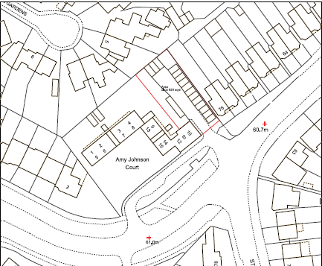

The Middle Way, Wealdstone HA3 7EG
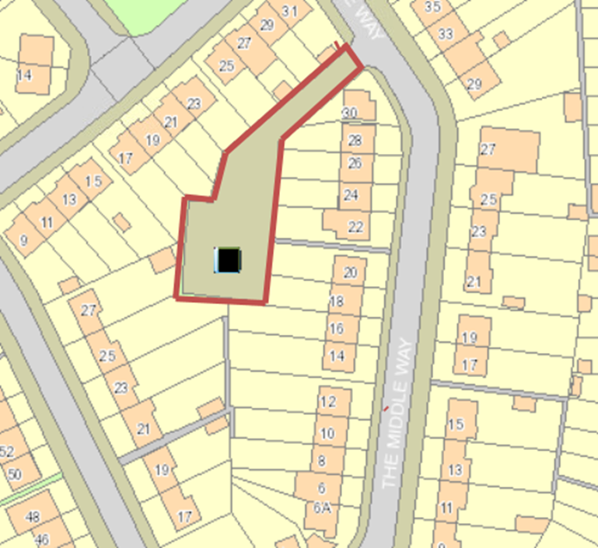

Hartington Close, Sudbury Hill HA1 3RL
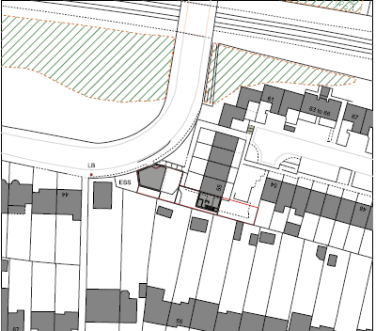

Ellement Close, Pinner HA5 1ER
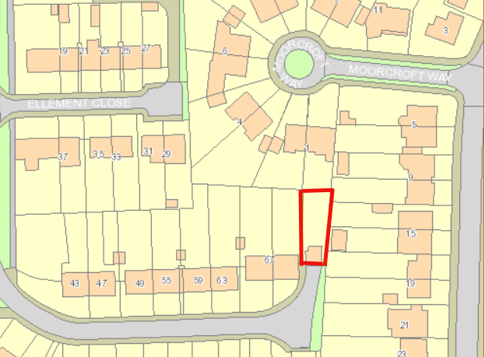

Westbere Drive Garages, HA7 4RQ
